**Course 8 overview: Set your expectations**

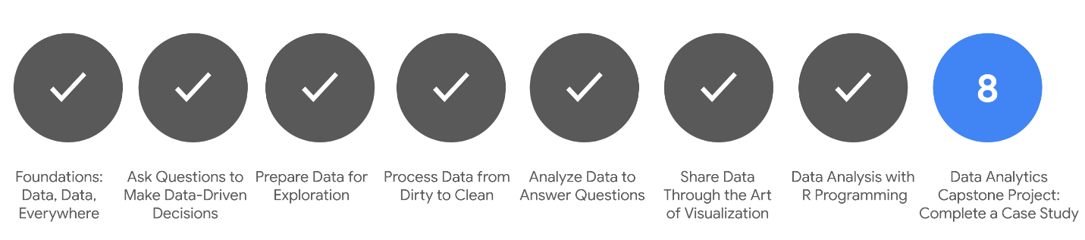

1. [Foundations: Data, Data, Everywhere](https://www.coursera.org/learn/foundations-data/home/welcome)
2. [Ask Questions to Make Data-Driven Decisions](https://www.coursera.org/learn/ask-questions-make-decisions/home/welcome)
3. [Prepare Data for Exploration](https://www.coursera.org/learn/data-preparation/home/welcome)
4. [Process Data from Dirty to Clean](https://www.coursera.org/learn/process-data/home/welcome)
5. [Analyze Data to Answer Questions](https://www.coursera.org/learn/analyze-data/home/welcome)
6. [Share Data Through the Art of Visualization](https://www.coursera.org/learn/visualize-data/home/welcome)
7. [Data Analysis with R Programming](https://www.coursera.org/learn/data-analysis-r/home/welcome)
8. **Google Data Analytics Capstone: Complete a Case Study** *(this course)*

You are approaching the last leg of your journey: the eighth and final course! You have gained the knowledge and job-ready skills to work as an entry-level data analyst. Through video vignettes, readings, journal entries, hands-on activities, online discussions, and networking with other learners, you now know what it takes to analyze and process data. You can find key insights and solve business problems using data.

To recap the highlights of your journey, you:

* Discovered data analysis, data analytics, and data ecosystems, and how data is used in organizational decision-making
* Learned how to ask SMART questions to make data-driven decisions, use spreadsheets, and work effectively with stakeholders
* Explored analytical thinking skills, the data analysis process, and the use of spreadsheets, SQL, and data visualizations as core data tools
* Practiced cleaning data in spreadsheets and SQL databases, and learned how important it is to verify, document, and report the cleaning process to ensure data integrity
* Organized, sorted, filtered, and aggregated data for analysis, and performed basic calculations with functions and formulas in spreadsheets, and SQL queries and temporary tables in databases
* Learned about design thinking, created visualizations and dashboards in Tableau, and worked on your communication skills to present engaging data-driven stories
* Wrote code in the R programming language to clean and analyze data, used RStudio to edit and run your code, and created detailed data visualizations in RStudio

**What to expect**

The Google Data Analytics Certificate Capstone Project is an opportunity for you to use many of the skills and competencies you gained from earlier courses. You have already invested many weeks in the program, so completing this capstone project is like a grand celebration of your learning achievements! The Capstone Project is optional, and choosing whether or not to complete it will not affect your ability to receive your certificate. However, it is highly recommended! Completing the Capstone Project is a great way to put everything you’ve learned together and will be useful for future job applications.

What’s next? After you go over what capstone projects, case studies, and portfolios are, you will be presented with realistic cases. You will then choose one of them to use as your case study. Or, as an alternative, you can think of a case that aligns with your personal interests and use that for your case study. This will be your chance to actually go through the six steps of the data analysis process from start to finish. Use the links at the top of this page to review any content in other courses in the program to help you complete your case study.

Then, after you complete your case study, you can include it in your online portfolio. Your project will boost your confidence! You will be able to refer to it as an example of your work when you interview for data analyst positions. And finally, after you complete your project, you can use the final materials in this course to help you prepare for a job interview. Good luck, and enjoy working on your case study.

**Course content**

Course 8 – Google Data Analytics Capstone: Complete a Case Study

1. **Capstone basics:** A capstone project in Coursera refers to a final project at the end of a study program. In the real world, these types of projects are more often referred to as case studies, Case studies are common ways for employers to assess the skills of prospective job candidates. In this part of the course, you will explore the benefits of using capstone projects, case studies, and portfolios to showcase your new skills to potential employers.
2. **Building your portfolio:** In this part of the course, you will be introduced to two tracks (and possible cases for you to use) to complete your capstone project. Depending on which track you choose, you will then be directed to specific lessons and instructions that are applicable to the track you selected. The final deliverable in either track is a finished case study for your online portfolio.
3. **Using your portfolio:** Having a case study in your portfolio is a first step. In this part of the course, you will focus on how you will use your portfolio to highlight skills that employers are looking for. You will develop an elevator pitch for your case study that enables people to quickly grasp a high-level understanding of what you did. Then, you can practice incorporating aspects of your case study into answers for different types of interview questions.

**Course deliverables**

Your final deliverables will include the following:

* Completed case study
* Online portfolio
* Elevator pitch (for your case study)
* Updated LinkedIn profile

Your case study won’t be graded, but use all resources provided to help you successfully complete it. Participate in the [**Discussion Forums**](https://www.coursera.org/learn/google-data-analytics-capstone/discussions) for this course to chat with others who are working on the same or similar case studies. Strategies may be shared, but not specific analysis steps or activities. If you don’t already have an account, set up one on the platform you have chosen to host your portfolio. Practice your elevator pitch for your case study or share it with others to fine tune it.

**Certificate requirements**

To qualify for the certificate, let us know if you've completed the optional case study (it's highly recommended) and pass all of the earlier required Course Challenges in the certificate with at least 80% correct answers. It’s certainly all right if you don’t pass a Course Challenge the first time you go through it. Before you try again, retake the practice quizzes to help you identify the topics you need to review. Then, go back to the videos and readings for those topics to better understand what you may have missed. You can take a Course Challenge up to three times to achieve a passing score.

You are on the path to getting your certificate soon!

**Updates to the course**

As you complete this course, you may notice updates to the content, like new practice materials and additional examples. These updates ensure the program provides up-to-date skills and guidance that will help you in your data analytics career. If you previously completed a graded activity, you *may* need to repeat the assessment in order to complete this course.  For more information, check out [the course discussion forum.](https://www.coursera.org/learn/google-data-analytics-capstone/discussions)

**Explore portfolios**

Earlier, you learned that a portfolio contains samples that you share with potential employers. Case studies are practice or example data analytics projects that you can create for your portfolio. After you have created your online portfolio, you can add a link to it on your resume. Having a portfolio to showcase who you are and demonstrate your skills will help you stand out to potential employers. The case study that you will complete in this course can be one of the examples that you add to your portfolio.



In this reading, you will learn some important things to keep in mind when building your portfolio. You will also explore GitHub and Kaggle, which are platforms that can host your portfolio. You will view the professional profiles of two data analysts and what they include in their portfolios on Kaggle.

**Ins and outs of building your portfolio**

First and foremost, your portfolio should represent your *own* work. While getting ideas from other portfolios is inspiring, directly copying (or only slightly modifying) others’ work and sharing it in your own portfolio is never acceptable.

Additionally, if you work on a project as a data analyst, keep in mind that the work you do for an employer or client belongs to their business. In many cases, you can’t share that work publicly in your personal portfolio without direct and explicit permission from them beforehand.



Finally, be cautious even with open or public datasets. Unless you are using data that you personally collected, ask the owner of the data for permission before you post anything related to the data in your portfolio. You should always take full responsibility for what you publish by getting the right permissions as needed.

As you begin to develop your portfolio, there are a few considerations you can use to help you decide how best to incorporate your work:

* **Choose your projects**: Select projects that resonate with your skills and career goals. Your portfolio should reflect a range of skills that connect directly to the work you would be doing as a data analytics professional.
* **Capture your process**: When discussing projects with potential employers, it’s more useful to focus on your process than on your results. Describe your strategies; discuss the tools you used; and explain the decisions you made along the way, as well as why you made them. This insight gives potential employers a glimpse into your problem-solving abilities and thought processes.
* **Aesthetics matter**: Your portfolio should be easy to navigate and visually appealing. Professionalism, simplicity, and engagement are key.
* **Tell your story:** Clearly explain the background of each project. What challenges did you face? What steps did you take to overcome them? And what impact did your work have? Consider all of the people who you are communicating with. Who are they and what do they need to know about you?

Now, let’s review three platforms you can use to host your portfolio.

**Personal websites**

Creating a **personal website** to host your portfolio is a great option because you can also use it to showcase aspects of your personality or background that contribute to your professional brand. For example, you might share a compelling experience that reflects your ability to collaborate, be resilient, or not give up. Whatever you choose to share, make sure that it is something you wouldn’t mind other people knowing about you.

For example, this visualization from data analyst [Bill Yost’s website](https://www.billyost.net/) demonstrates his ability to create a Tableau visualization but also tells a very personal story about his battle with cancer. Potential employers get an idea of his skills and find out a lot more about who he is at the same time.

Notice that although the annotations in the visualization appear somewhat crowded in the white space (per guidelines in the [Share Data Through the Art of Visualization](https://www.coursera.org/learn/visualize-data/supplement/ewNyk/pro-tips-for-headlines-subtitles-and-labels) course), the concept of sharing a personal story is the main takeaway.

**GitHub**

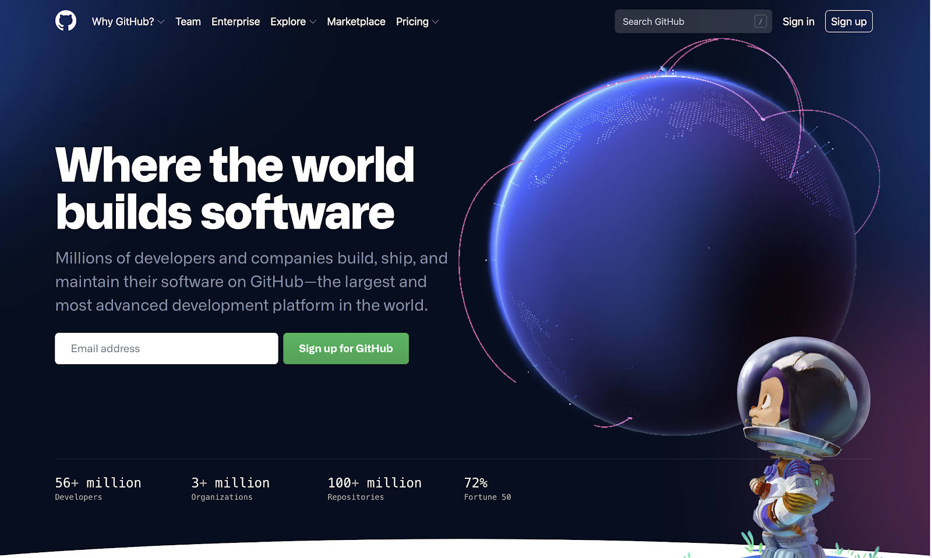

**GitHub** is a hosted platform primarily used by developers as a repository for code, but it can also be used as a repository for documentation. One of the tips you have been given in this program is to keep an electronic journal of things to remember, especially for SQL or R syntax. If something in your electronic journal is particularly useful, you can create a document for your portfolio in GitHub. For inspiration, check out this [R usage tips](https://github.com/erikaduan/R-tips/blob/master/README.md) readme document a GitHub user posted.

**Kaggle**

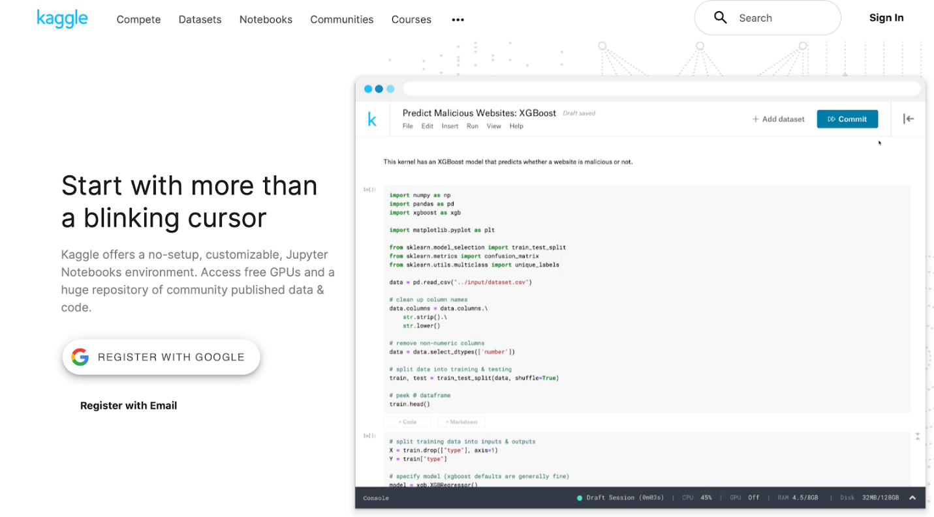

If you have an account on **Kaggle**, you can also use it as a platform to host your portfolio and personal background. Check out these profile examples:

* [Jesse Mostipak's profile](https://www.kaggle.com/jessemostipak)
* [Meg Risdal's profile](https://www.kaggle.com/mrisdal)

Their profiles showcase competitions they have participated in, datasets they have created, and discussions they have contributed to. Kaggle **competitions** are challenges that people take on at any stage of their programming and machine learning careers. Check out this YouTube video to learn [how to enter a Kaggle competition](https://www.youtube.com/watch?v=GJBOMWpLpTQ). Both Jesse’s and Meg’s profiles also include links to follow them on other social media platforms, like LinkedIn and Twitter.

**Jupyter Notebook** is an open-source web application that you can use to create and share documents that contain live code, equations, visualizations, and narrative text. Kaggle supports a Jupyter Notebook environment that can be accessed from a browser. Jesse and Meg also have notebooks in Kaggle. You can use Kaggle to create your own notebooks for potential employers to view.

* Click [Jesse Mostipak's Notebooks link](https://www.kaggle.com/jessemostipak/notebooks) to view her notebooks
* Click [Meg Risdal's Notebooks link](https://www.kaggle.com/mrisdal/notebooks) to view her notebooks

**Your portfolio and case study checklist**

It is important to understand the key components of both a portfolio and case study, as both are essential to success when applying for jobs. The following are checklists to help cover your bases. If you'd like to refer to this checklist in the future, you can download the PDF below:

[Your portfolio and case study checklist.pdf](https://d3c33hcgiwev3.cloudfront.net/NQfW0r6WQsmH1tK-luLJeg_cf9d5450675649f1a49897eda567916d_Your-portfolio-and-case-study-checklist.pdf?Expires=1706918400&Signature=NAe~39jHvRuHTYE0bCITuFSKdAg-~IKUZ9rmkCsFeS9nC~X6hZgYRJDBZypSvE9gPWgKnfdW2yhESQmP-Dh61p0jsKu0j2MHZEYraNBBWwioVWbzC5ihU2Dtfz3~cmGopNfpy~I1xbE2-zUi4oWIu7vQf3krPdgAfXOYPKaJ6Nw_&Key-Pair-Id=APKAJLTNE6QMUY6HBC5A" \t "_blank)

[PDF File](https://d3c33hcgiwev3.cloudfront.net/NQfW0r6WQsmH1tK-luLJeg_cf9d5450675649f1a49897eda567916d_Your-portfolio-and-case-study-checklist.pdf?Expires=1706918400&Signature=NAe~39jHvRuHTYE0bCITuFSKdAg-~IKUZ9rmkCsFeS9nC~X6hZgYRJDBZypSvE9gPWgKnfdW2yhESQmP-Dh61p0jsKu0j2MHZEYraNBBWwioVWbzC5ihU2Dtfz3~cmGopNfpy~I1xbE2-zUi4oWIu7vQf3krPdgAfXOYPKaJ6Nw_&Key-Pair-Id=APKAJLTNE6QMUY6HBC5A" \t "_blank)

**What to include in your portfolio**

Even if you don’t have previous data analytics work experience, you can still craft a great portfolio that represents your new skills and offers insight into who you are. Be sure to include the following in your portfolio:

* **Biography**: The main focus of your portfolio is to introduce yourself in a strong and memorable way. Write a concise and clear introduction of yourself. The goal is to capture your audience’s interest and compel them to want to meet you to learn more.
* **Contact page**: Be sure to include a way for others to get in touch with you, whether it be via email, phone call (if you are comfortable), or social media handles (especially LinkedIn). You might find that your website has its own built-in contact form if you use common website builders.
* **Resume**: In previous readings, [Add technical skills to your resume](https://www.coursera.org/learn/process-data/supplement/8FBgn/add-technical-skills-to-your-resume) and [Add professional skills to your resume](https://www.coursera.org/learn/process-data/supplement/U8xZj/add-professional-skills-to-your-resume), you learned how to craft a resume that reflects your skills and your experience. Be sure to include a resume somewhere in your portfolio.
* **Accomplishments**: You are not just limited to your past experiences. Any present career-worthy highlights you can think of should be included. This can be any certifications you have earned, data analytics events you have attended, or even blog posts you have published.
* **An image of you (optional)**: Add a personal touch with your photo. All you need is a simple, clear photo that represents you well.

**What to include in a case study**

During your interview process, you will very likely encounter the case study interview. In this interview, you will be provided with a business-related scenario where you analyze a problem and come up with the best solution. You will have a certain amount of time to solve this so it is best to be prepared for any scenario you are given. A great case study will include the following:

* **Introduction**: Make sure to state the purpose of the case study. This includes what the scenario is and an explanation on how it relates to a real-world obstacle. Feel free to note any assumptions or theories you might have depending on the information provided.
* **Problems**: You need to identify what the major problems are, explain how you have analyzed the problem, and present any facts you are using to support your findings.
* **Solutions**: Outline a solution that would alleviate the problem and have a few alternatives in mind to show that you have given the case study considerable thought. Don’t forget to include pros and cons for each solution.
* **Conclusion**: End your presentation by summarizing key takeaways of all of the problem-solving you conducted, highlighting what you have learned from this.
* **Next steps**: Choose the best solution and propose recommendations for the client or business to take. Explain why you made your choice and how this will affect the scenario in a positive way. Be specific and include what needs to be done, who should enforce it, and when.

**Examples of interview case study questions**

Get a better idea of an employer's expectations from the case study questions in this blog article: [4 Case Study Questions for Interviewing Data Analysts at a Startup](https://www.holistics.io/blog/startup-data-analyst-interview-case-studies/).

# Revisit career paths in data

In a reading in the [Foundations: Data, Data, Everywhere](https://www.coursera.org/learn/foundations-data/supplement/VUMX2/data-analyst-roles-and-job-descriptions) course, you learned about three different career paths in data science: data analyst, data scientist, and data specialist. This reading revisits the data analyst career choice (first column in the table below) to explore how the skills you have learned in this program match up with real job requirements.

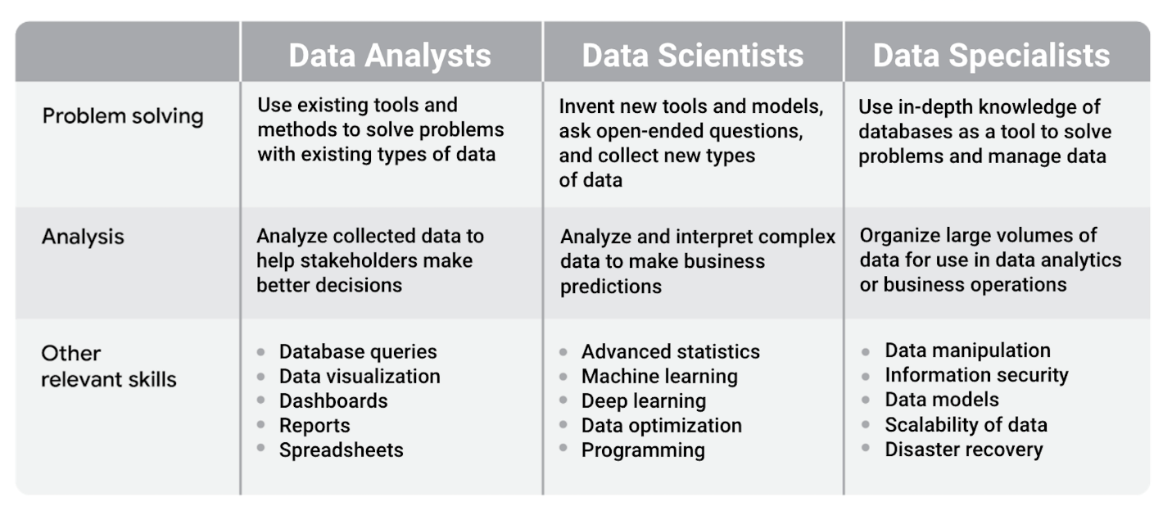Data analysts: -problem solving: use existing tools and methods to solve problems with existing types of data -analysis: analyze collected data to help stakeholders make better decision -other relevant skills: database queries, data visualization, dashboards, reports, and spreadsheets Data scientists: -problem solving: Invent new tools and models, ask open-ended questions, and collect new types of data -analysis: analyze and interpret complex data to make business predictions -other relevant skills: advanced statistics, machine learning , deep learning, data optimization, and programming Data specialists: -problem solving: use in-depth knowledge of databases as a tool to solve problems and manage data -analysis: organize large volumes of data for use in data analytics or business operations -other relevant skills: data manipulation, information security, data models, scalability of data, and disaster recover

## Mapping certificate skills to job requirements

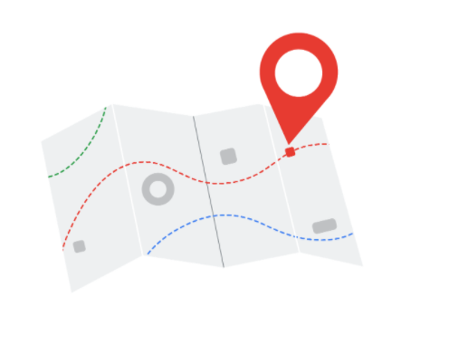

The skills you gain with the Google Data Analytics Certificate align with skills that data analyst jobs require. When you create your resume, the way you present your skills can capture the attention of a recruiter or a hiring manager. Many career counselors recommend that you customize your resume each time you apply for a job so that your experience and skills align as closely as possible with the requirements listed in the job description.

For each of the relevant skills in the previous table, consider the following:

* Possible phrases from job descriptions
* Examples of matching skills from this certificate

Let’s go through the skills for data analysts and examine common phrases you might find in job descriptions.

### **Skill: database queries**

| **Job description phrase** | **Skills from this program you could include in your resume** |
| --- | --- |
| Collect data by using a scripting language such as SQL | - Perform SQL queries - Sort and filter data using SQL queries - Convert data types using SQL functions |

### **Skill: data visualization**

| **Job description phrase** | **Skills from this program you could include in your resume** |
| --- | --- |
| Visualize data insights and communicate your findings to teams in other organizations | - Create data visualizations using Tableau - Create visuals in spreadsheets - Create presentations from data analysis results |

### **Skill: dashboards**

| **Job description phrase** | **Skills from this program you could include in your resume** |
| --- | --- |
| Build and train users of new dashboards | - Identify the data needs of users - Create dashboards using Tableau - Use design thinking to improve dashboards |

### **Skill: reports**

| **Job description phrase** | **Skills from this program you could include in your resume** |
| --- | --- |
| Create comprehensive reports | - Create data cleaning reports - Create and maintain change logs - Create reports in R Markdown |

### **Skill: spreadsheets**

| **Job description phrase** | **Skills from this program you could include in your resume** |
| --- | --- |
| Explore and analyze datasets with spreadsheets | - Clean data in spreadsheets - Sort and filter data in spreadsheets - Create pivot tables in spreadsheets |

### **Skill: programming**

This is an area where you can potentially distinguish yourself from other candidates when you apply for a data analyst position. Programming is considered a more advanced or higher-level skill and might not even be in a job description for a junior data analyst role. You learned to use R for data analysis as part of this program, and adding programming skills to your resume might make your application stand out.

| **Job description phrase** | **Skills from this program you could include in your resume** |
| --- | --- |
| Knowledge of some programming languages and an organized and methodical approach to work | - Install and use the tidyverse package in R - Run scripts in RStudio - Create data visualizations in RStudio |

## Aiming for more technical roles

If your goal is to work in a more technical role like a data scientist, the Google Data Analytics Certificate is a good starting point. But you might need to pursue additional learning opportunities to advance your skills, such as:

* Completing other professional certificates (Coursera offers many)
* Registering for college courses as a part-time or full-time student and applying for paid internships
* Continuing your education in a four-year college degree program like computer science, data science, or management information systems

For more information about career paths in data science, including roles that are more technical, refer to this article on Medium: [Career Paths Within Data Science](https://medium.com/ds3ucsd/career-paths-within-data-science-4243679c04b9).

**Next steps**

The Capstone Project case study is an optional component of these courses. However, it is highly recommended as an opportunity to demonstrate everything you’ve learned so far and build your portfolio for future job applications. The following diagram provides an overview of the next steps that you will take to finish this course. You will complete a case study, create an online portfolio, update your LinkedIn profile, and prepare to interview for data analyst jobs.

Sections of this reading will direct you to resources in this course and other courses in the program that will help you complete each step.

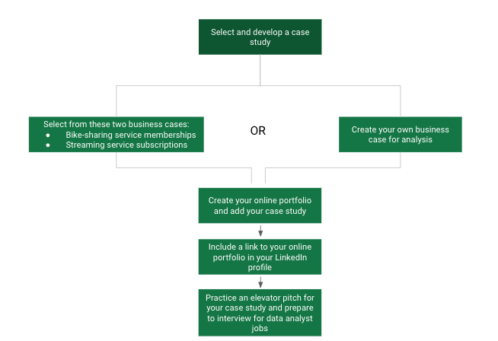1. Select and develop a case study 2. Select from these two business cases: - Bike-sharing service memberships - Streaming service subscriptions OR 2. Create your own business case for analysis 3. Create your online portfolio and add your case study 4. Include a link to your online portfolio in your LinkedIn profile 5. Practice an elevator pitch for your case study and prepare to interview for data analyst jobs

**Selecting and developing a case study**

In this course, you have options for selecting and developing a case study. You can choose one of two possible tracks.

The first track has two cases already defined. You can pick one of these cases and follow through on the data analysis to answer the questions presented to address business problems. For more information, refer to the [track A details](https://www.coursera.org/learn/google-data-analytics-capstone/supplement/bY66y/track-1-details).

The second track allows you to design your own case study about a topic that you are interested in. You can practice all but the Act phase of the Data Analysis Process: Ask, Prepare, Process, Analyze, Share, and Act. For more information, refer to the [track B details](https://www.coursera.org/learn/google-data-analytics-capstone/supplement/zbwbs/track-2-details). You can also return to [The phases of data analysis and this program](https://www.coursera.org/learn/foundations-data/lecture/JjA1f/the-phases-of-data-analysis-and-this-program) video to review the steps of the Data Analysis Process.

After familiarizing yourself with the details of each track, refer to the information in [Choose your case study track](https://www.coursera.org/learn/google-data-analytics-capstone/supplement/NTV8r/choose-your-case-study-track) and decide which track you want to follow.

**Creating your online portfolio**

After completing your case study, you will create an online portfolio to store and display it. Refer to [Create your online portfolio](https://www.coursera.org/learn/google-data-analytics-capstone/supplement/m86c7/create-your-online-portfolio). It provides an overview of platforms that can potentially host your portfolio and case study.

**Updating your LinkedIn profile**

In an earlier course, you learned about creating an online presence with a LinkedIn account in [Getting started with LinkedIn](https://www.coursera.org/learn/data-preparation/supplement/3QDa4/get-started-with-linkedin). Access your LinkedIn profile again to add a link to your online portfolio in your profile.

**Practicing your case study pitch**

You can start to prepare for interviews by creating an elevator pitch for your case study. Refer to [What makes a great pitch](https://www.coursera.org/learn/google-data-analytics-capstone/supplement/y5U2D/what-makes-a-great-pitch) to understand the kinds of questions to prepare for. Try to include aspects of your elevator pitch in your answers to the sample questions provided in the reading. Then, practice pitching your case study as part of your planned responses to commonly asked interview questions.

Your portfolio and case study checklist It is important to understand the key components of both a portfolio and case study, as both are essential to success when applying for jobs. The following are checklists to help cover your bases. What to include in your portfolio Even if you don’t have previous data analytics work experience, you can still craft a great portfolio that represents your new skills and oers insight into who you are. Be sure to include the following in your portfolio: Biography: The main focus of your portfolio is to introduce yourself in a strong and memorable way. Write a concise and clear introduction of yourself. The goal is to capture your audience’s interest and compel them to want to meet you to learn more. Contact page: Be sure to include a way for others to get in touch with you, whether it be via email, phone call (if you are comfortable), or social media handles (especially LinkedIn). You might find that your website has its own builtin contact form if you use common website builders. Resume: In previous readings, Adding Professional Skills to your Resume and Adding Soft Skills to your Resume, you learned how to craft a resume that reflects your skills and your experience. Be sure to include a resume somewhere in your portfolio. Accomplishments: You are not just limited to your past experiences. Any present career-worthy highlights you can think of should be included. This can be any certifications you have earned, data analytics events you have attended, or even blog posts you have published. An image of you (optional): Add a personal touch with your photo. All you need is a simple, clear photo that represents you well. What to include in a case study During your interview process, you will very likely encounter the case study interview. In this interview, you will be provided with a business-related scenario where you analyze a problem and come up with the best solution. You will have a certain amount of time to solve this so it is best to be prepared for any scenario you are given. A great case study will include the following: Introduction: Make sure to state the purpose of the case study. This includes what the scenario is and an explanation on how it relates to a real-world obstacle. Feel free to note any assumptions or theories you might have depending on the information provided. Problems: You need to identify what the major problems are, explain how you have analyzed the problem, and present any facts you are using to support your findings. Solutions: Outline a solution that would alleviate the problem and have a few alternatives in mind to show that you have given the case study considerable thought. Don’t forget to include pros and cons for each solution. Conclusion: End your presentation by summarizing key takeaways of all of the problem-solving you conducted, highlighting what you have learned from this. Next steps: Choose the best solution and propose recommendations for the client or business to take. Explain why you made your choice and how this will a ect the scenario in a positive way. Be specific and include what needs to be done, who should enforce it, and when.

# Introduction to building your portfolio

In this part of the course, you will prepare a case study that you can include in your online portfolio. All of the resources provided will help you to succeed in this goal (referred to as the Google Data Analytics Capstone).

There is an old saying that you learn by doing. You have already learned about the importance of each phase in the data analysis process when working with a dataset. You will soon learn about the importance of having an online portfolio. The Google Data Analytics Capstone will enable you to actually put the two together—a dataset you took through the data analysis process for your portfolio.

By completing your capstone project, you will practice:

* Going through the Ask, Prepare, Process, Analyze, and Share phases of the data analysis process
* Stating a business task clearly
* Importing data from a real dataset
* Documenting any data cleaning that you perform on the dataset
* Analyzing the data
* Creating data visualizations from your analysis
* Summarizing key findings from your analysis
* Documenting your conclusions and recommendations
* Creating and publishing your case study

Your case study will demonstrate these fundamental skills to prospective employers and showcase what you have learned from the Google Data Analytics Certificate. It will represent your knowledge and capabilities in your portfolio.

**Resources to explore other case studies**



Inspiration is everywhere. You can get ideas for a case study to include in your portfolio from your hobbies, travels, children, volunteer work, and even something as common as waiting in line! For example, you might create a case study examining the effect of customer wait times on a company’s sales.

Let’s imagine you enjoy fishing. You can create a case study for your portfolio that relates to your hobby. It is helpful to browse Medium, GitHub, Tableau, and Kaggle to get an idea of what other people have already created and find some inspiration.

**Searching on Medium**

To search for case studies on Medium, go to [medium.com/search](https://medium.com/search).

Enter the term *fishing*,as an example. Medium will pull up a bunch of articles that are related to fishing. You can also explore topics related to fishing by clicking other tags on the right: Environment, Travel, Fishing and Travel, Outdoors, and more.

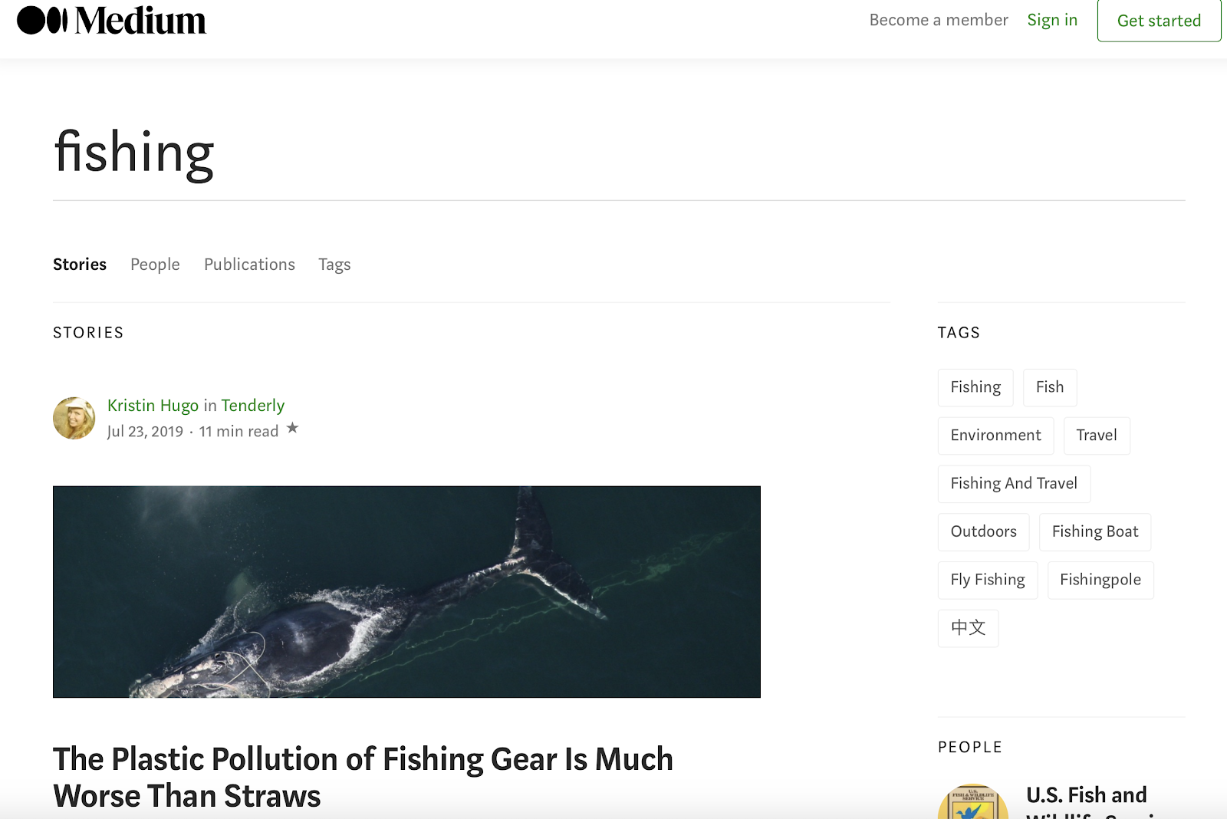

**Searching on GitHub**

To search for case studies on GitHub, go to [github.com/search](https://github.com/search).

If you enter *fishing* in the search field, GitHub returns thousands of results. If you enter *fishing case study* in the search field, GitHub returns fewer results.

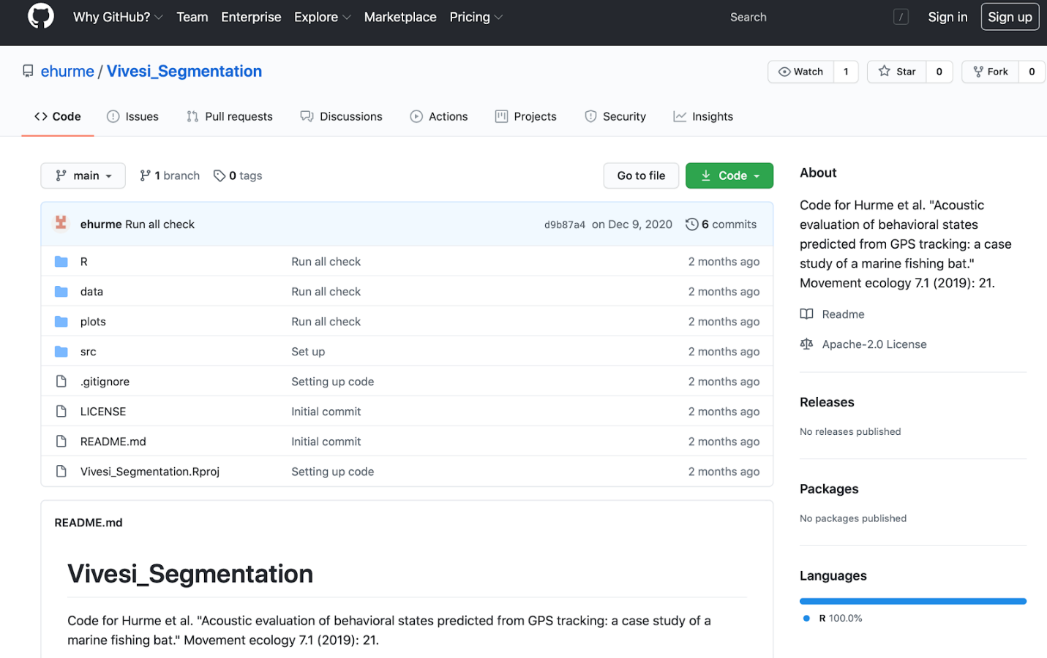

**Searching on Tableau**

To search for case studies in Tableau, go to [public.tableau.com](http://public.tableau.com/) and use the search bar at the top of the page.

For example, click the search icon (the magnifying glass) and enter *fishing*. The term *fishing* returns thousands of results.

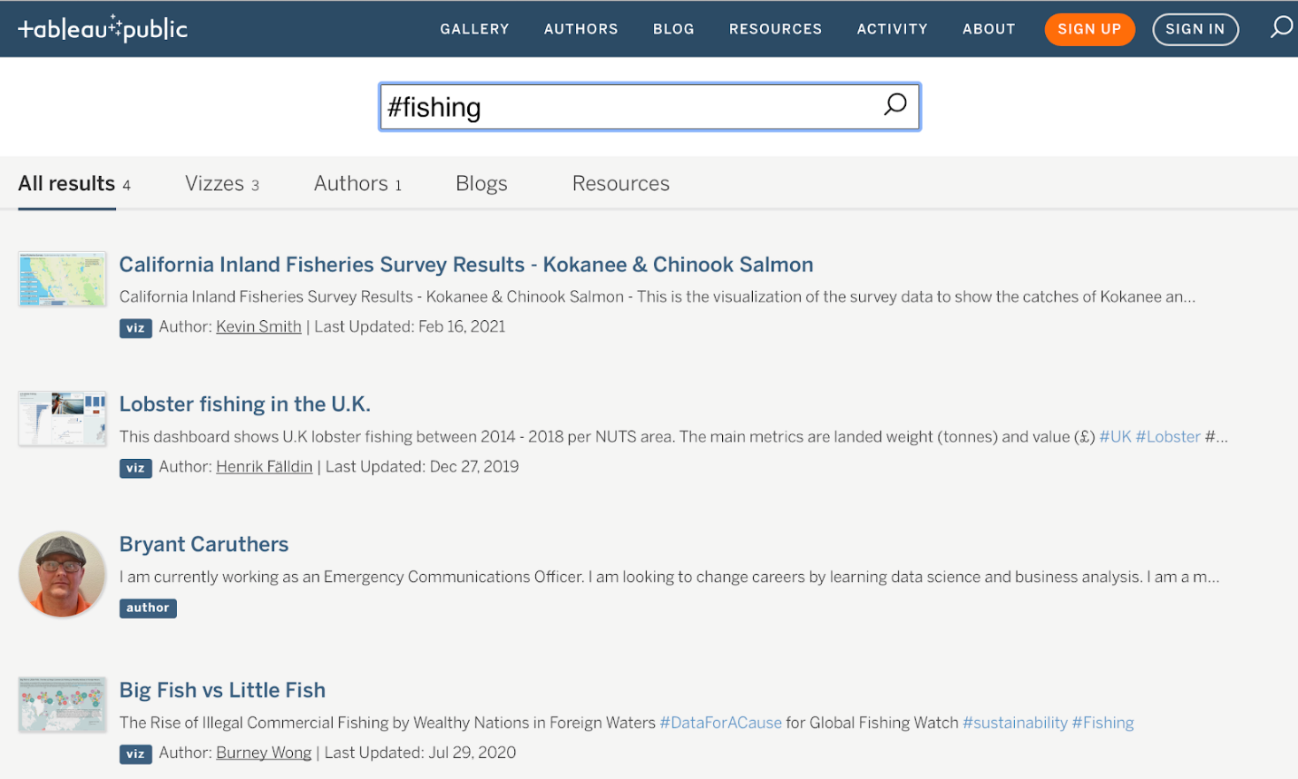

**Searching on Kaggle**

To search for case studies on Kaggle, go to [kaggle.com](https://www.kaggle.com/) and use the search bar. For example, if you enter *fishing* in the search bar at the top of the page, you get results similar to the ones displayed below.

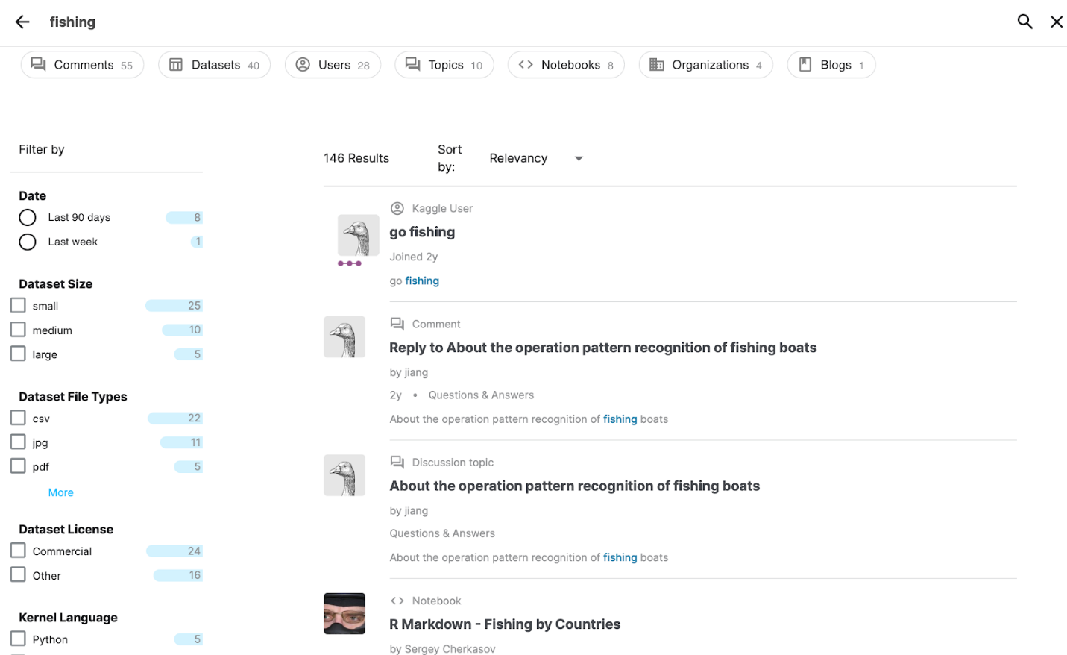

The *R Markdown - Fishing by Countries* notebook in Kaggle might be promising. You discover from this notebook that there is a public domain dataset called *Annual Nominal Fish Catches: Explore the impact of overfishing in the Northeast Atlantic region.*

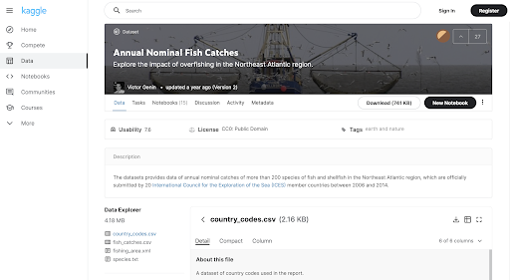

You might have just found a great dataset to use to create your own case study. You wouldn’t want to repeat the same analysis related to overfishing, but the data could reveal another pattern worth analyzing.

**Key takeaway**

You can use the same procedure completed for the fishing example to search for case studies and data about any other topic that interests you. By including case studies that are personally meaningful to you in your portfolio, you give prospective employers a better sense of the kind of person you are and what inspires your work.

**Create your online portfolio**



This reading provides a checklist about what to include in your portfolio, where you can set up accounts to host your portfolio, and how to add content to your portfolio.

**What to include**

You learned that a portfolio represents your skills and showcases some of your previous projects to potential employers. Keep your portfolio:

* **Personal:** Show who you are, what you are interested in, and what is important to you.
* **Simple:** Display your work with easy navigation and without cluttered pages.
* **Relevant:** Match your work to the skills included in job descriptions.
* **Presentable:** Emphasize quality in the samples you show.
* **Unique:** Showcase your own work; cite sources of content to avoid plagiarism.

**Where to set up accounts**

Choose a platform to host your portfolio. Medium, Google Sites, and Wordpress are good for blogging. GitHub and Kaggle are better for code. And finally, as you know, Tableau is great for visualizations. Next, create an account on the platform that you chose. Check out these steps to set up accounts on various platforms:

* [Set up an account on GitHub](https://docs.github.com/en/github/getting-started-with-github/signing-up-for-a-new-github-account)
* [Set up an account on Kaggle](https://www.kaggle.com/questions-and-answers/122858)
* [Set up an account on Tableau Public](https://public.tableau.com/s/) – *Click the orange "Sign Up" button*
* [Set up an account on Medium](https://help.medium.com/hc/en-us/articles/115004915268-Sign-in-or-sign-up-to-Medium)
* [Set up an account on WordPress](https://wordpress.com/start/user)
* [Set up a site on Google Sites](https://support.google.com/sites/answer/6372878?hl=en&ref_topic=7184580)

**How to add content to your portfolio**

Finally, refer to the following table for some links to articles that can help you to manage your portfolio. Articles are free but some sites limit the number of articles you can view per month. In that case, bookmark the article to view it later.

| **Platform** | **Information to help you manage your portfolio** |
| --- | --- |
| GitHub | [8 steps to publishing your portfolio on GitHub](https://medium.com/tunapanda-institute/8-steps-to-publish-your-portfolio-on-github-9d6e6e3d2e84): Follow the steps in this article to create a repository for your portfolio. |
| Kaggle | [Publishing your first dataset on Kaggle](https://medium.com/analytics-vidhya/publishing-your-first-dataset-on-kaggle-6be8c37e59e8): Follow the steps in this article to publish your own dataset and make it public. |
| Tableau | Any visualization created in Tableau Public is already public by default. A lot more is involved to add a Tableau visualization to another hosted site. For that reason, it is probably best to link to Tableau visualizations when your portfolio is hosted on a personal website or on a different platform, like GitHub. |
| Medium | [Getting started with a Medium publication](https://help.medium.com/hc/en-us/articles/115004681607-Getting-started-with-a-Medium-publication): Follow the process in this guide to create your own publication. |
| WordPress | [Get Published](https://wordpress.com/learn/get-published/): Follow these instructions to create pages or post content on your site. |
| Google Sites | [Publish & share your site](https://support.google.com/sites/answer/6372880): Follow these instructions to publish your site and share it publicly. [Use a custom domain for your site](https://support.google.com/sites/answer/9068867): Refer to these instructions if you want to use a custom URL for your portfolio. |

**Introduction to sharing your work**

In this part of the course, you will learn about how to include aspects of your Google Data Analytics Capstone(case study) in your responses to data analyst interview questions.



It’s important for you to establish the mindset of a data analyst in the real world. This part of the course prepares you to use that mindset when you talk about your case study during interviews, which will ultimately help you be successful in your interviews with recruiters and hiring managers.

In this week's content, different interview scenarios will be presented as useful examples. You will have the opportunity to:

* Familiarize yourself with interview practices and questions
* Develop your own strategies for using your portfolio and case study
* Create and polish your elevator pitch for your case study
* Practice introducing your case study at a high level and at the right time during interviews
* Access resources that will help you become more confident telling recruiters and hiring managers about your case study when you interview for data analyst roles

Your case study demonstrates fundamental skills to prospective employers and showcases what you have learned from the Google Data Analytics Certificate. But being able to present these skills and discuss your case study during interviews is also going to be key to your success!

# The interview process

Think of your job interview process as having four stages: introduction, skills test, compatibility, and decision-making. In this reading, you’ll review the different stages to help you better prepare. Along the way, you’ll learn more about Interview Warmup, a tool designed specifically to help you practice your interview skills. This is a great way to gain confidence before your actual interviews.

## Interview stages

You will likely be required to go through multiple rounds of interviews. Each interview will vary in the types of questions asked and what is expected of you. Continue reading to learn about different types of interviews.

### Stage 1: Introduction (resume and portfolio)

The goal of the introductory interview is for the recruiter to get to know you. They want to find out who you are and assess your background. This is your chance to shine. Have your portfolio and resume ready and be prepared to speak concisely about your qualifications, experience, and skills using specific examples.

### Stage 2: The skill test interview (case study)

This is usually your second interview and it will often be conducted by a fellow data analyst or data engineer. In this interview, you will be given a technical assessment testing your SQL and programming skills. You will also be asked to complete a case study or a behavioral test. Your potential employer wants to know if you can do the job that you’re interviewing for, so they will be focused on getting you to demonstrate your skills. Make sure you’re prepared with well-formed answers that highlight your technical knowledge and problem-solving skills.

### Stage 3: The compatibility interview

In some cases, there will be an additional interview to determine mutual compatibility between you and the company. To give you a comprehensive idea of what the work culture is like, the interviewer might include other members of the team during this round.



Often the goal here is to determine if you are a good fit with the rest of the team that you will be working with. This might include your peers, as well as the person you might report to. As with the introductory interview, get ready to discuss yourself more in-depth, using examples from your portfolio and resume as needed.

### Stage 4: Decision-making

When your last interview concludes, it’s advisable to ask about next steps and a timeline of when a hiring decision will be made. Take note that the process can take anywhere from four-to six weeks as things are finalized.

You will likely receive one of three responses: an offer letter, a rejection letter, or no communication. Receiving a job offer is very exciting and something you can take pride in. However, don’t feel pressured or obligated to accept the first offer you receive. Feel free to ask for time to consider, do your research on a fair salary or benefits package, and be open-minded and willing to compromise.

## Build your network

Unfortunately, there are times when you will receive a rejection. Despite any disappointments you may have, responding back with a thoughtful email will create a professional relationship with that hiring manager or company. You may even stand out in a way that might benefit your career in the long run. Generally, this email should be a short thank you letter expressing your appreciation for the opportunity and for the time they spent interviewing you.



There will even be cases where you will receive no response from the hiring manager. This doesn’t necessarily mean you did not get the position and sending an inquiring follow-up email will help clear things up. However, if you indeed didn’t get the position, then simply accept it and continue applying for jobs. Remember, every rejection is an opportunity to practice your interviewing skills.

## Practice interview skills

Now that you’ve learned about the different interview stages, it’s time to practice interviewing. You can get useful interview experiences by answering questions you might encounter in an actual interview.

Being enrolled in this certificate program gives you access to [Interview Warmup](https://www.cloudskillsboost.google/interview-warmup), which is a tool that helps you become more confident and comfortable throughout the interview process. Interview Warmup asks you interview questions to practice delivering your responses verbally. Your answers will be transcribed in real time, allowing you to review how you responded. In addition, Interview Warmup's machine learning algorithm can detect insights that can help you learn more about your answers and improve the way you communicate.

Here are some of the insights that Interview Warmup provides:

* **Talking points:** The tool lets you know which topics you covered in your answer, such as your experience, skills, and goals. You’ll also be able to view other topics that you might want to consider covering.
* **Most-used words:** The tool highlights the words you used most often and suggests synonyms to broaden your word choices.
* **Job-related terms:** The tool highlights the words you used that are related to the role or industry in which you are preparing to work. You’ll also be able to view an entire list of job-related terms that you might want to consider including in your answer.

To access Interview Warmup, follow these steps:

1. Go to [grow.google/interview-warmup](http://grow.google/interview-warmup).
2. Click **Start practicing**.
3. Select **Data Analytics** to open an additional menu.
4. Select **Data Analytics** again as the field you wish to practice.
5. Click **Start**.

The interview lasts about 10 minutes, and the questions will vary with each attempt. During each interview session, you will be asked two background questions, one behavioral question, and two technical questions. You are encouraged to try as many practice interviews as you want. This is a great way to practice the interview tips you learned about in this course!

## Key takeaways

Persistence is an important part of landing a job interview, continuing your job search, and acing the interview. Finding a job is hard work and you have plenty of resources to help guide you through the process. Keep applying and continue practicing your interviewing abilities until you find that perfect job!

**Scenario video series introduction**

Data analytics is an exciting field that can involve tons of different industries and specializations. As a trained data analyst, you will have a wide variety of opportunities to choose from. Before you get there, though, there is still one last part of your career journey that you have to master: the interview process.



Potential interviewers will ask you lots of different types of questions to ensure that you are both a great technical fit for the job, and an overall personable and professional person. In the upcoming series of lessons, the featured videos will guide you through different scenarios you might come across during a typical job interview. In these scenarios, you will meet the job applicant, Sally, a recently certified data analyst, and Jordan, the head of human resources. Sally applied to a job at BWR Technical Services and was asked to participate in an interview.

To use the template for the job application posting, click the link below and select “Use Template.”

Link to template: [Job application posting](https://docs.google.com/document/d/1wJh2mlh-baGQw0i6Uh_up-yQmq9EvibyFSK3mTmb0JE/template/preview)

Or, If you don’t have a Google account, you can download the file directly from the attachment below.

[Junior Data Analyst Job Application](https://d3c33hcgiwev3.cloudfront.net/7w0_A1GdT1WNPwNRnW9V9Q_cb261c8f47814749858c3d0204cf14ed_Junior-Data-Analyst-Job-Application.docx?Expires=1706918400&Signature=ZWjHi2kgXqKdhFpKvaWGt0JzBMfS4wHVaWYmjOaIxbBrVQtKVZVkJ7~LsRMcOM81-ErLn~ViHq8w2quS0ocrUXHqngKxNQdx~4YMb~Q20T6-0GUKoHiQMIr-byR-F~pvPQgpyOEwrx0m1tEmiimJFWwDhS4PlzaTJX7u6JqN4yc_&Key-Pair-Id=APKAJLTNE6QMUY6HBC5A" \t "_blank)

[DOCX File](https://d3c33hcgiwev3.cloudfront.net/7w0_A1GdT1WNPwNRnW9V9Q_cb261c8f47814749858c3d0204cf14ed_Junior-Data-Analyst-Job-Application.docx?Expires=1706918400&Signature=ZWjHi2kgXqKdhFpKvaWGt0JzBMfS4wHVaWYmjOaIxbBrVQtKVZVkJ7~LsRMcOM81-ErLn~ViHq8w2quS0ocrUXHqngKxNQdx~4YMb~Q20T6-0GUKoHiQMIr-byR-F~pvPQgpyOEwrx0m1tEmiimJFWwDhS4PlzaTJX7u6JqN4yc_&Key-Pair-Id=APKAJLTNE6QMUY6HBC5A" \t "_blank)



**1. Introduction**: The purpose of this first video lesson in the series titled, [Scenario video: Introductions](https://www.coursera.org/learn/google-data-analytics-capstone/lecture/wrtl6/scenario-video-introductions) is for Jordan to get to know Sally and gain insight into her personality and background. This is the part of the interview when the interviewer usually answers questions about the company and the position. It’s also an opportunity for the applicant to outline how the skills they used in past roles can translate into the position they are applying for.

**2. Case study**: In this next video lesson titled, [Scenario video: Case study](https://www.coursera.org/learn/google-data-analytics-capstone/lecture/QVEOb/scenario-video-case-study), Sally is tasked with solving an assigned challenge of improving student grades by communicating a plan to outline her thinking, ask key questions, recommend solutions to parents, and more.

To use the Power point template for the case study presentation, click the link below and select “Use Template.”

Link to Power point template: [Case study presentation example](https://docs.google.com/presentation/d/1sGM5w0zbf_5HS2aiTLFZEaVfIfn0Yea8zkQ5O5eTIfc/template/preview)

Or, If you don’t have a Google account, you can download the file directly from the attachment below.

[Bridging the Communication Gap between Teachers & Parents](https://d3c33hcgiwev3.cloudfront.net/YHq4VQG1S2W6uFUBtWtlTw_27f958f4d1b64dee92e4888bb9353872_Bridging-the-Communication-Gap-between-Teachers-Parents.pptx?Expires=1706918400&Signature=jAHjbL0XtNPY6F9Lduoj1qZ4wAg4AAMM1wj7SQEKFoeIAGCJSBKN~NspKEgbTrLiUl7GWushGcUwkcmEypQu8T0yyiJf38BHqj~9a0l~ROCL~xizEBMZx-7esoK97qlj0mSyNd9HRjw2PkDfS36UgObJKM3oJNLledtvZHlltEM_&Key-Pair-Id=APKAJLTNE6QMUY6HBC5A" \t "_blank)

[PPTX File](https://d3c33hcgiwev3.cloudfront.net/YHq4VQG1S2W6uFUBtWtlTw_27f958f4d1b64dee92e4888bb9353872_Bridging-the-Communication-Gap-between-Teachers-Parents.pptx?Expires=1706918400&Signature=jAHjbL0XtNPY6F9Lduoj1qZ4wAg4AAMM1wj7SQEKFoeIAGCJSBKN~NspKEgbTrLiUl7GWushGcUwkcmEypQu8T0yyiJf38BHqj~9a0l~ROCL~xizEBMZx-7esoK97qlj0mSyNd9HRjw2PkDfS36UgObJKM3oJNLledtvZHlltEM_&Key-Pair-Id=APKAJLTNE6QMUY6HBC5A" \t "_blank)



**3. Solving problems**: In the next lesson titled, [Scenario video: Problem-solving](https://www.coursera.org/learn/google-data-analytics-capstone/lecture/Vzxva/scenario-video-problem-solving), most interviewers will ask applicants questions related to their problem-solving abilities. In this video, Sally provides specific examples of past challenges and how she used her problem-solving skills to overcome them.

**4. Salary negotiation**: Once the interviews are over, if the company offers you the position, you and the company both need to agree on your starting salary. Although it is often an uncomfortable part of the process for many job applicants, negotiating a salary that you feel is fair is very important. In this final video lesson of the series titled, [Scenario video: Negotiating terms](https://www.coursera.org/learn/google-data-analytics-capstone/lecture/MS5NP/scenario-video-negotiating-terms), the video highlights how Sally has done her research and didn’t feel pressured to accept the company’s first offer on the spot.

When it comes to job interviews, there is no such thing as being too prepared. Be sure to do your research on the company, the role you are applying to, and salary expectations for the position. Practice marketing yourself and your skills and use active listening whenever you are asking and answering questions.

**What makes a great pitch**



There is a certain question that you will probably be asked throughout your career, especially during professional interviews: “Tell me about yourself?” This can be tricky to answer well, but the goal is to positively and accurately represent yourself using your past and present experiences and skills–essentially, you need to pitch yourself. In this reading, you will learn how to promote yourself as an effective and highly skilled data analyst in a job interview. Even if you don’t have any professional data analysis work on your resume yet, experience and skills you gained from previous work of any kind can be useful to share if you pitch it the right way.

To help you prepare, here are some possible questions you might be asked in an interview, including technical questions to assess specific practical knowledge and questions that require you to apply your own personal experiences.

**Technical questions**

* *“What are your preferred tools for analysis?”* This is a chance to demonstrate that you are well-versed in data analysis, with proficiency in SQL, Excel, and R programming.
* *“How do you maintain integrity in your data?”* Reliability and accuracy are essential parts of good data analysis, and any issues with your data can have a major impact on data-driven business decisions. Be prepared to discuss the methods you use for error checking and validation.
* *“Do you understand different SQL functions and the roles they play?”* SQL is arguably one of the most important skills for you to have as a data analyst. This is an opportunity to demonstrate your understanding of different types of SQL functions and their value or result.

**Personal experience questions**

* “*Was there a time when you took initiative during a project and what was the outcome?*” This question can come in many forms with slightly different wording, but the goal is to understand your leadership abilities and how you have used them in the past.
* “*What was the most challenging project you have ever been faced with*?” This question is usually meant to assess your problem-solving and interpersonal skills. Come to the interview prepared with several different examples of how you successfully navigated a difficult project or situation in the past.
* “*How would you explain a complex topic to a stakeholder who was unfamiliar with it*?” This question helps your interviewer get a sense of how skilled you are at communicating effectively in high-pressure or sensitive circumstances.
* “*How do you cope when things don’t go according to plan?*” It is important to be adaptable, especially when things don’t go the way you expected. This question provides a great opportunity for you to explain how you coped with unexpected changes and adapted quickly to a different course of action.

Try crafting answers to each of these questions and coming up with fitting examples for each scenario. Write the answers down and practice them until they feel natural and unrehearsed.

**Prepare yourself**

There is no way for you to know exactly what your interviewer will ask you. But preparing some polished and professional answers to common interview questions can be incredibly helpful. Learning how to successfully pitch yourself and your skills as a data analyst takes practice. The more you practice, the more comfortable you will likely be during the actual interview, regardless of what questions you get asked.

**Top tips for interview success**

You just learned about some best practices when it comes to data analyst interviews. Read on for four final preparation tips to help set you up for interviewing success.

**Tip 1: Find connections between the job listing and your resume**

First, re-read your resume and the job description to help you draw lines between the two. Where do they connect? Then, as you interview, include specific keywords or phrases from the job description that match skills you possess or achievements you have accomplished previously in your career.

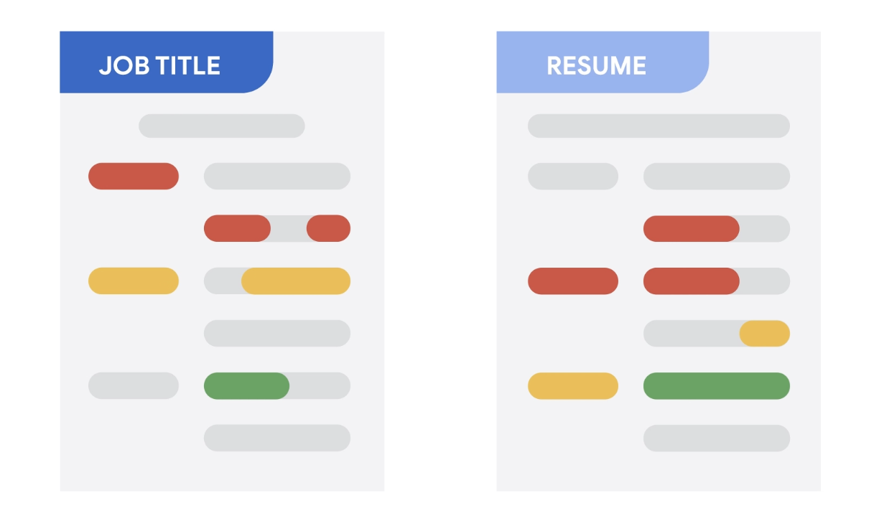

**Tip 2: Focus on data**

As you start to think about things you want to highlight in your interview, don’t forget to include *data*. This helps your interviewer understand not just your overall achievements, but how big of an impact you made. What data can you provide that tells the story of your experience in terms of the needs of this position? The “equation” we suggest including goes something like this: *I accomplished X as measured by Y doing Z*. Here’s an example: “I increased customer satisfaction by 22% in three months by designing a new digital onboarding process.”

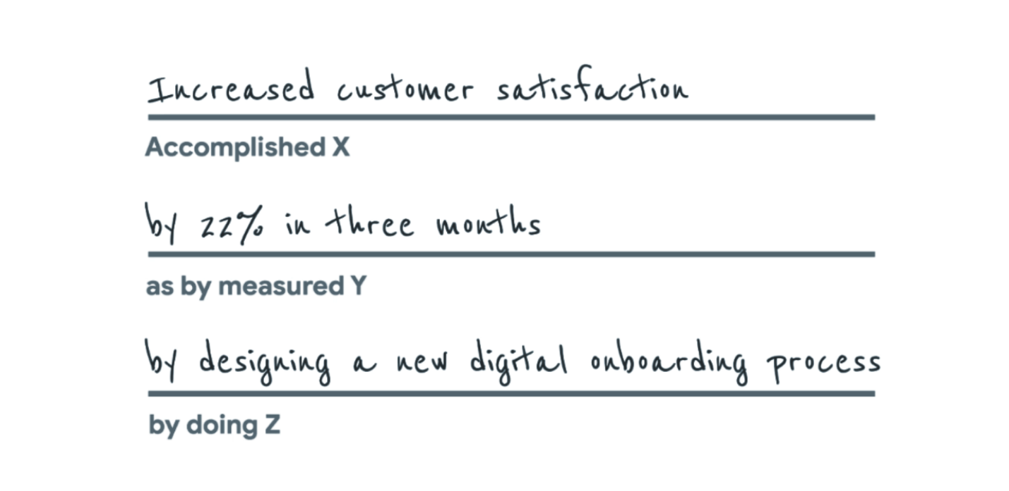Accomplished X: Increased customer satisfaction as by measured Y: by 22% in three months by doing Z: by designing a new digital onboarding process

If you don’t have access to this kind of data from a previous position, you can still indicate the scope you were accountable for and strengthen the language you use when describing your responsibilities by including action words like *provided*, *created*, *developed*, *supported*, *implemented*, and *generated.* For example: “I implemented a new scheduling system that led to 95% of the team meeting deadlines.”

**Tip 3: Look back at past work experiences**

Review your work history. That may not sound like something you need to prepare for, but most of us have done more than we think and it’s easy to forget some of our own wins (and lessons learned from mistakes).

Think of examples of times you achieved something so you are prepared to answer questions  like “Tell me about a time when . . .” or “How would you approach this situation . . .?"



**Tip 4: Come ready with questions**

Next, come to the interview with your own questions, such as “What are some upcoming projects I’d be working on? What current goals is the company focused on? Can you tell me about the team I’ll be working with?” This not only shows you care about understanding the company and the position you’re applying for, but it’s also a testament to the research you’ve done by looking into the company. Besides, this is your opportunity to interview them as well.

This type of preparation will help you feel confident and prepared to talk about yourself and the position. It will enable you to fully explore your experience, the position, and your career aspirations and really connect with the employer!

**Prepare for interviews with Interview Warmup**

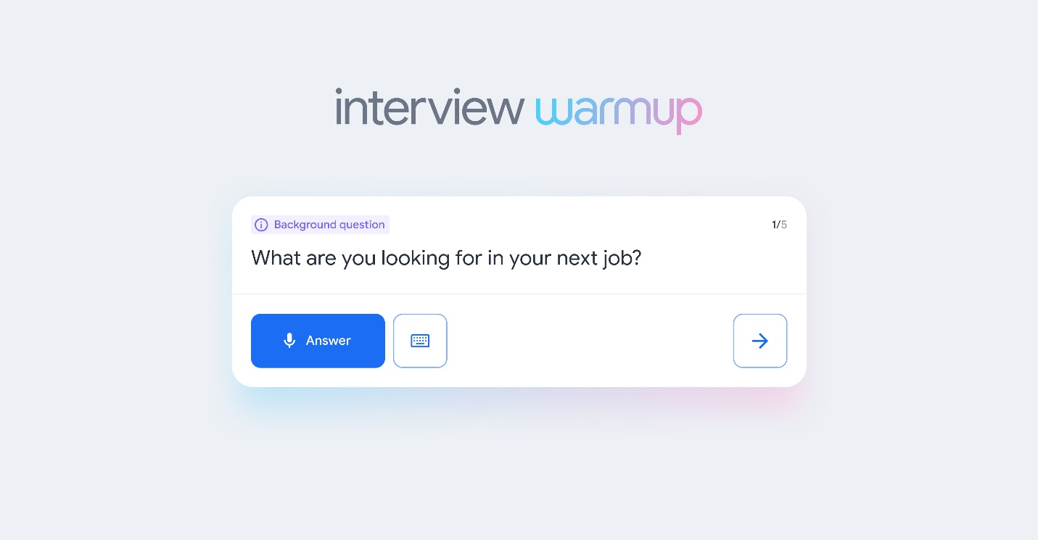

Now that you have the skills and knowledge to work in data analytics, it’s time to start preparing for interviews. [Interview Warmup](https://grow.google/certificates/interview-warmup/) is a tool that helps you practice answering questions to get more confident and comfortable with interviewing.

**Get started**

Follow these steps to start a 5-question practice interview related to data analytics:

1. Go to [grow.google/interview-warmup](http://grow.google/interview-warmup).
2. Click **Start practicing.**
3. Select the **Data Analytics** practice set.
4. Click **Start.**

It takes about 10 minutes, and the questions will be different every time. Each question set will have two background questions, one behavioral question, and two technical questions, simulating what you would encounter in a real interview. You can try as many practice interviews as you want.

You’ll also have the option to access the full list of interview questions if you’d like to review more of the questions available or focus on specific topics.

**How it works**

Interview Warmup asks interview questions for you to practice answering out loud. It transcribes your answer in real time so you can review what you said. You’ll also review insights, which are patterns detected by machine learning that can help you discover things about your answers and identify ways to keep improving.

Here are a few examples of questions the tool might ask:

* Can you tell me why you are interested in a role in data analytics?
* Describe the difference between structured and unstructured data.
* Imagine you've run into a challenge with an analysis and you aren't sure how to address it. What are some steps you might take to seek help?
* Can you describe what a subquery is in SQL?
* What is reproducible data analysis? What are some of its benefits?

Here are some of the insights that Interview Warmup provides:

* **Talking points:** The tool lets you know which topics you covered in your answer, such as your experience, skills, and goals. You’ll also be able to view other topics that you might want to consider covering.
* **Most-used words:** The tool highlights the words you used most often and suggests synonyms to broaden your word choices.
* **Job-related terms:** The tool highlights the words you used that are related to the role or industry in which you are preparing to work. You’ll also be able to view an entire list of job-related terms that you might want to consider including in your answer.

Interview Warmup gives you the space to practice and prepare for interviews on your own. Your responses will be visible only to you, and they won’t be graded or judged.

**Key takeaways**

Practicing for interviews is an important skill for your career in data analytics. Using Interview Warmup can help you practice interview questions and receive feedback in real time. As you practice, you will gain confidence and be able to prepare more polished responses for common interview questions.

# Negotiate your contract



Picture this: you have made it through the end of the interview process and great news- the hiring manager wants to offer you the position. Your first instinct may be to accept the offer without paying attention to all the details in the offer contract. You should resist this instinct and do your due diligence. Read through the offer letter carefully, looking at what is offered aside from salary, compare it with what is expected for the role, and most importantly remember that this is a negotiation, but you have power in this situation. Negotiating a job offer is an essential part of the interview process, even for entry-level roles. Let's take a closer look at how to be prepared when the time comes.

### **Research**



Hopefully by this time, you will have done your research on the role - not only on the qualifications for the job, but also the average salary expectations. Knowing the average salary for a junior data analyst in your location is the best way to determine if the offer you received is fair. Keep in mind what makes you stand out as a candidate as it might give you insight as to whether you should ask for more or identify when you have received a generous offer. Always ask for the range that the team is targeting and which components of the offer the company will consider. For example, does the company offer sign-on bonuses? Additional equity? Merit increases? This will give you an idea not just of what you are receiving at the moment but the potential for growth as well.

### **Don’t just focus on money**

A salary that compensates you well for your work is great, but you must also consider benefits. You want to keep in mind some of the things that are important to you and whether or not a potential employer can provide access to them as a part of your compensation package. This would include sign-on bonuses, vacation days, paid time off, sick days, retirement plans, healthcare coverage, and more. If they are unable to increase your starting salary, you may want to explore asking for benefits or more perks to be included in your starting package.

### **Negotiate**

In certain cases, you might be asked if you have a rate or salary range in mind at the beginning of the interview process. While this question might seem straightforward, it is important to not respond with a specific number before knowing the actual number for the role because the moment you do, you will be giving up negotiating power.



A contract negotiation often starts with the potential employer providing you with an offer letter with general details about your compensation package. This is their initial offer and companies will often expect your request changes to the package, whether it be more money or additional benefits. This is referred to as a counter-offer. Once a counter-offer is made the potential employer will try to reconcile what you are asking for with what they initially proposed and find a middle ground if possible.

Always remember that negotiation is your right and it is not considered impolite. On the contrary, showing initiative in negotiating displays your confidence and tenacity to advocate for yourself. If you react with a well-researched counteroffer, it will also demonstrate that you are intelligent enough to know your value.

### **Focus on long-term growth**



While a negotiated offer is common, don’t be discouraged if your counter offer is not met.  Unless you have competing offers, you will likely still decide to take the job if it’s a fair offer. If it makes practical sense to take the initial offer, you should consider reevaluating in 12 months or whenever you have amassed more experience and will have more leverage to work with.

Pay close attention to the following video, which will demonstrate an interview where the candidate displays their negotiating abilities.

# Showcase your work

Congratulations on earning your Google Data Analytics Certificate! Now it’s time to let the world know about the skills you gained to help advance your career and share some of the artifacts you created along the way. We recommend adding the completion of this certificate to your resume and LinkedIn profile. Read on and follow these tips to get started.

## ****Adding the Google Data Analytics Certificate to your resume and LinkedIn profile****

You may have already started on a data analyst resume earlier in the certificate. If not, there are a variety of digital templates for creating your resume available at [Enhancv](https://app.enhancv.com/industry-examples), [Big Interview](https://googlecerts.biginterview.com/), [Google Docs](https://applieddigitalskills.withgoogle.com/c/middle-and-high-school/en/create-a-resume-in-google-docs/overview.html) or [Microsoft Word.](https://support.microsoft.com/en-us/office/use-a-template-to-create-a-resume-6053fbbb-94d8-471e-9957-49f4e7ab6fb8) You can find additional resume creation guidance in this lesson from Applied Digital Skills: [Start a Resume](https://applieddigitalskills.withgoogle.com/c/college-and-continuing-education/en/start-a-resume/overview.html)

### **Update your Education or Licenses and Certifications section**

* To add the completion of this certificate to your resume, update your ***Education*** or ***Licenses & Certifications*** section.
* To add the completion of this certificate to the ***Licenses & Certifications*** section of your LinkedIn profile, follow the [steps listed in this article.](https://www.linkedin.com/help/linkedin/answer/44644)

Education: google data analytics certificate, coursera 2021 associate of arts, KC community college, central, IL 2018

### **Update your Skills section**

* If applicable, update the ***Skills*** section of your resume. Below is a comprehensive list of skills that this certificate was designed to help you develop that you could potentially add.
* To update the ***Skills & Endorsements*** section of your LinkedIn profile, follow the [steps listed in this article.](https://www.linkedin.com/help/linkedin/answer/4976)

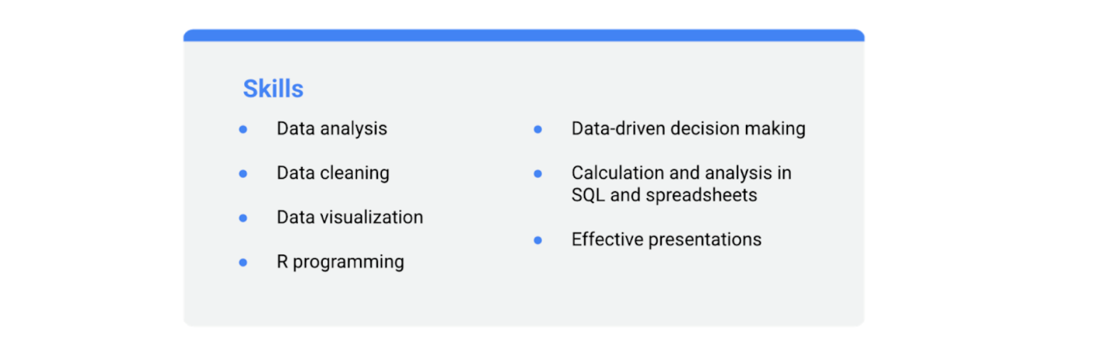- data analysis - data cleaning - data visualization - R programming - data-driven decision making - calculation and analysis in SQL and spreadsheets - effective presentations

### **Update your Summary or About section**

* If you have a ***Summary*** section in your resume, you can include this certification as a qualification.
* To include a summary that mentions this certification in your LinkedIn profile, update your ***About*** section by following the [steps listed in this article.](https://www.linkedin.com/help/linkedin/answer/92157)

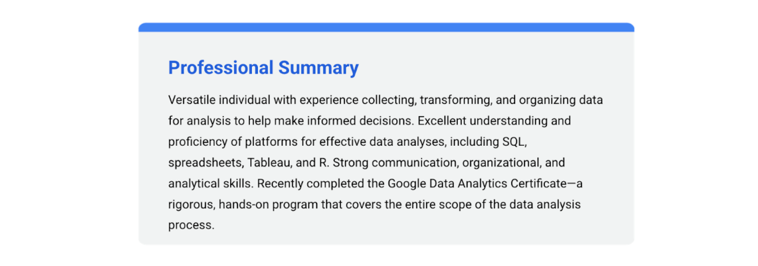Versatile individual with experience collecting, transforming, and organizing data for analysis to help make informed decisions. Excellent understanding and proficiency of platforms for effective data analyses, including SQL, spreadsheets, Tableau, and R. Strong communication, organizational, and analytical skills. Recently completed the Google Data Analytics Certificate- a rigorous, hands-on program that covers the entire scope of the data analysis process.

### **Add your badge**

Check out the next course item to learn how to claim your certification completion badge and add it to your LinkedIn profile!

# Sign up to the Big Interview platform

Since preparation is key to nailing interviews and landing a new job, we’ve worked with [Big Interview](https://biginterview.com/), an online interview preparation platform, to create interactive interview tools specifically for data analytics learners like you.

We’re excited to be able to offer you 12 months of free access (originally a $79/month value) as part of the Google Data Analytics Certificate! You’ve earned it.

On **Big Interview** you can:

* Practice answering interview questions in a recorded environment that allows you to get feedback and hone your interviewing skills
* Prepare a resume using their resume-building tool

Follow the steps below to sign up for your **Big Interview** account and start practicing:

1. Go to [googlecerts.biginterview.com/](https://googlecerts.biginterview.com/).
2. Click **Register**.
3. Register with your name, email address, and password.
4. Log in.
5. Go to the **Learn** page.
6. Click **Google Certificates Practice Sets**.
7. Choose **Data Analytics** to begin practicing!

**Expand your data career expertise**

Congratulations again on completing the Google Data Analytics Certificate! By now, you have wrapped up your capstone project, claimed your Certificate badge, and may be exploring new professional opportunities. You might also want to find ways to continue expanding your knowledge. That’s great– a huge part of being a data professional is continuing to learn!

There are two advanced Google Career Certificates that are designed to build on the foundational knowledge you developed in this program: the [Google Business Intelligence Certificate](https://www.coursera.org/google-certificates/google-business-intelligence) and the [Google Advanced Data Analytics Certificate](https://www.coursera.org/google-certificates/google-advanced-data-analytics). If you are interested in growing your career as a data professional, this reading has information about these two advanced Google Career Certificates.

**Business intelligence versus advanced data analytics**

Business intelligence (BI) uses processes and tools to turn raw data into easy-to-understand, actionable information. For example, creating dynamic and impactful dashboards helps stakeholders gain critical insights into the performance of an organization. The [Google Business Intelligence Certificate](https://www.coursera.org/google-certificates/google-business-intelligence) builds on your data analytics skills and helps unlock more career opportunities. You will practice your skills with hands-on activities using BigQuery, SQL and Tableau.

Advanced data analytics uses math and statistics, programming, artificial intelligence (AI), and machine learning (ML) to uncover insights within an organization’s data structure. These insights can be used to guide stakeholder decision-making and strategic planning. The [Google Advanced Data Analytics Certificate](https://www.coursera.org/google-certificates/google-advanced-data-analytics) will diversify your knowledge of analytics beyond the numbers to develop storytelling, advanced predictive modeling, and visualization techniques. You will complete hands-on activities using Jupyter Notebook, Python, and Tableau.

While both of these fields are concerned with data, they have different interests and approaches to that data:

|  |  |  |
| --- | --- | --- |
| **Career information** | **Business intelligence (BI)** | **Advanced data analytics** |
| **Job overview** | BI professionals build tangible solutions, such as databases and dashboards, to meet the needs of stakeholders. Stakeholders use these databases and dashboards to make critical business decisions. | Data professionals try various techniques and models to learn about data and generate insights. Stakeholders use these insights to make decisions. |
| **Job titles that you can prepare for with this certificate** | Business intelligence analyst  Business intelligence engineer  Business intelligence developer  Business data analyst  Business analyst | Senior data analyst  Junior data scientist  Data science analyst  Data analytics scientist  Data analytics consultant |
| **Job openings and median salary** | There are over 166,000 open jobs in business intelligence, and the median salary for entry-level roles is $96,000.¹ | There are over 144,000 open jobs in advanced data analytics, and the median salary for entry-level roles is $118,000.¹ |
| **Problem types** | Examples of problems you would solve as a BI professional include measuring performance, tracking revenue or spending, and monitoring progress. | Examples of problems you would solve as an advanced data analytics professional include determining the likelihood for a particular user behavior, predicting events that may happen in the future, and understanding the cause of a problem. |
| **Daily tasks** | BI professionals understand business needs, retrieve and organize data, create data visualizations, and build dashboards and reports. | Advanced data analytics professionals explore large datasets, apply data analysis techniques, and build models in order to find insights from the data. |
| **Carryover from these courses** | If you enjoyed analyzing data to inform decision-making or working with SQL, Tableau, and data visualizations in this certificate program, the Google Business Intelligence Certificate may be a great next choice for you! | If you enjoyed uncovering patterns and trends or working with programming languages and math in this certificate program, the Google Advanced Data Analytics Certificate may be a great next choice for you! |

1Lightcast™ US Job Postings (Last 12 Months: Jan. 1, 2022 - Dec. 31, 2022).

**Key takeaways**

As you continue your career in the data field, there will be many opportunities to further your learning, including the [Google Business Intelligence Certificate](https://www.coursera.org/professional-certificates/google-business-intelligence) and [Google Advanced Data Analytics Certificate](https://www.coursera.org/professional-certificates/google-advanced-data-analytics).  These certificate programs will expand your knowledge and provide you with the technical skills needed to take the next step in your career.